

***School of Mechanical & Manufacturing Engineering (SMME),***

***National University of Science and Technology (NUST),***

***Sector H-12, Islamabad***

Program: BE-Aerospace Section: AE-01

Session: Fall 2023 Semester: 1st

Course Title: Fundamental of Programming

Assignment # 01

***Name: ZAHIKA IHSAN***

***CMS:*** ***461202***

**Question No.1:**

Write a C++ program, take two strings as input from user and check if both strings are equal or not. If they are equal make them unequal by rotating string. e.g., Hello is turned into olleH etc.

**Answer:**

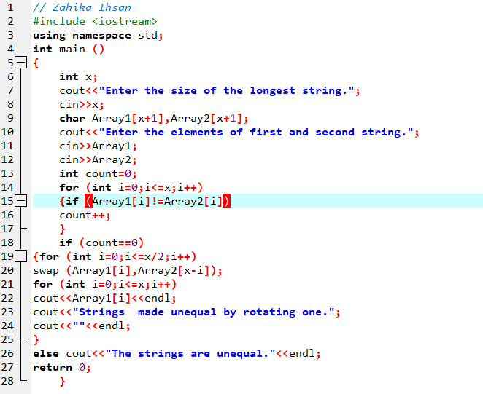

Figure 1 Input

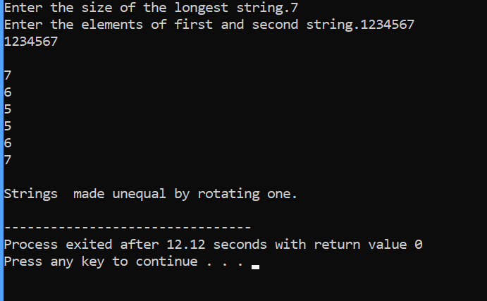

Figure 2 Output

// Zahika Ihsan

#include <iostream>

using namespace std;

int main ()

{

int x;

cout<<"Enter the size of the longest string.";

cin>>x;

char Array1[x+1],Array2[x+1];

cout<<"Enter the elements of first and second string.";

cin>>Array1;

cin>>Array2;

int count=0;

for (int i=0;i<=x;i++)

{if (Array1[i]!=Array2[i])

count++;

}

if (count==0)

{for (int j=0;j<=x/2;j++)

swap (Array1[j],Array2[x-j]);

for (int j=0;j<=x;j++)

cout<<Array1[j]<<endl;

cout<<"Strings made unequal by rotating one.";

cout<<""<<endl;

}

else cout<<"The strings are unequal."<<endl;

return 0;

}

**Input :** **Output:**

**Question No.2:**

Write a C++program for a string which may contain lowercase and uppercase characters. The task is to remove all duplicate characters from the string and find the resultant string.

**Answer:**

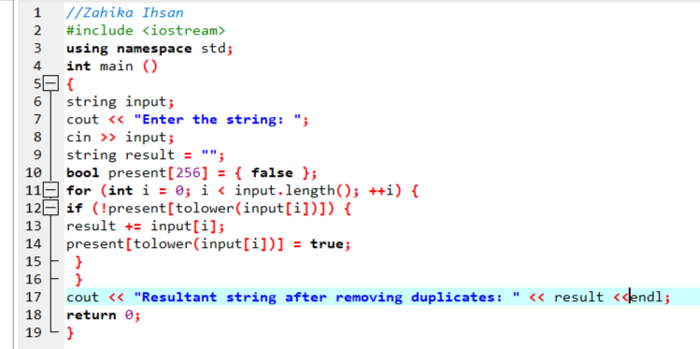

Figure 3 Input

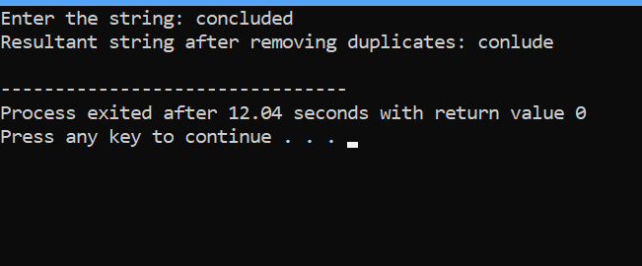

Figure 4 Output

//Zahika Ihsan

#include <iostream>

using namespace std;

int main ()

{

string input;

cout << "Enter the string: ";

cin >> input;

string result = "";

bool present[256] = { false };

for (int i = 0; i < input.length(); ++i) {

if (!present[tolower(input[i])]) {

result += input[i];

present[tolower(input[i])] = true;

}

}

cout << "Resultant string after removing duplicates: " << result <<endl;

return 0;

}

**Input**:   **Output:**

**Question No.3:**

Suppose an integer array a[5] = {1,2,3,4,5}. Add more elements to it and display them in C++.

**Answer:**

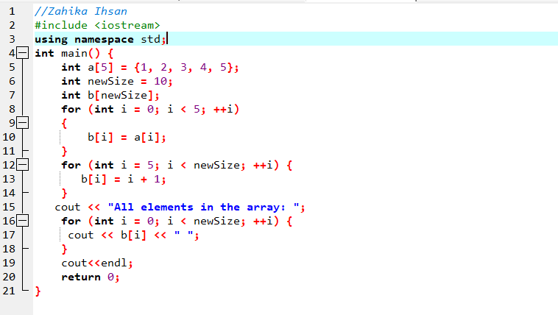

Figure 5 Input

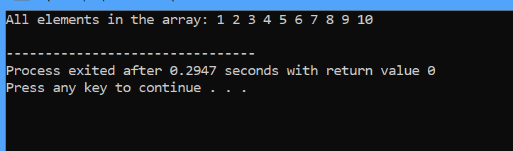

Figure 6 Output

//Zahika Ihsan

#include <iostream>

using namespace std;

int main() {

int a[5] = {1, 2, 3, 4, 5};

int newSize = 10;

int b[newSize];

for (int i = 0; i < 5; ++i)

{

b[i] = a[i];

}

for (int i = 5; i < newSize; ++i) {

b[i] = i + 1;

}

cout << "All elements in the array: ";

for (int i = 0; i < newSize; ++i) {

cout << b[i] << " ";

}

cout<<endl;

return 0;

}

**Input:**  **Output: **

**Question No.4:**

Write a C++ program that uses a while loop to find the largest prime number less than a given positive integer N. Your program should take the value of N as input from the user and then find the largest prime number less than or equal to N. You are not allowed to use any library or pre-existing functions to check for prime numbers.

**Answer:**

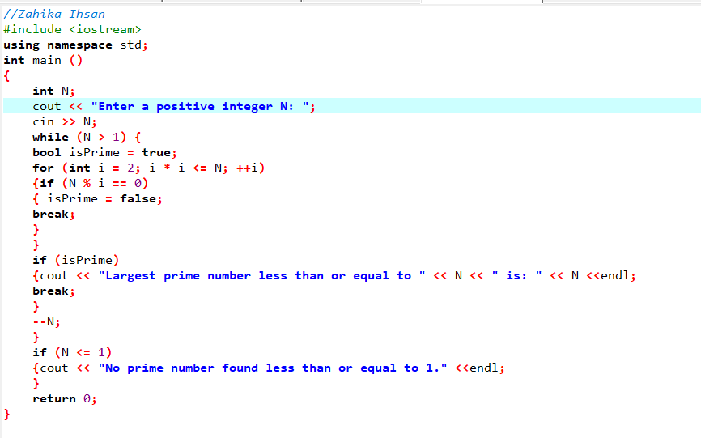

Figure 7 Input

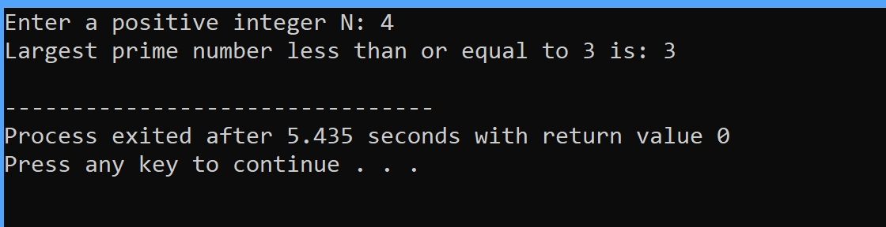

Figure 8 Output

#include <iostream>

using namespace std;

int main ()

{

int N;

cout << "Enter a positive integer N: ";

cin >> N;

while (N > 1) {

bool isPrime = true;

for (int i = 2; i * i <= N; ++i)

{if (N % i == 0)

{ isPrime = false;

break;

}

}

if (isPrime)

{cout << "Largest prime number less than or equal to " << N << " is: " << N <<endl;

break;

}

--N;

}

if (N <= 1)

{cout << "No prime number found less than or equal to 1." <<endl;

}

return 0;

}

**Input:**  **Output:**

**Question No.5:**

Implement Bubble Sort on an array of 6 integers.

**Answer:**

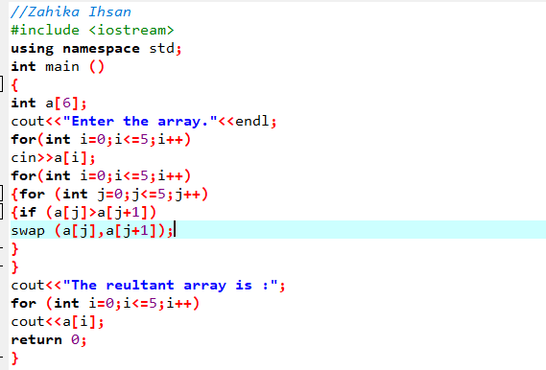

Figure 9 Input

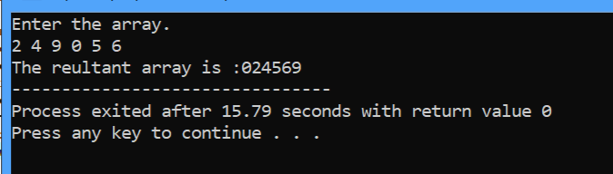

Figure 10 Output

//Zahika Ihsan

#include <iostream>

using namespace std;

int main ()

{

int a[6];

cout<<"Enter the array."<<endl;

for(int i=0;i<=5;i++)

cin>>a[i];

for(int i=0;i<=5;i++)

{for (int j=0;j<=5;j++)

{if (a[j]>a[j+1])

swap (a[j],a[j+1]);

}

}

cout<<"The reultant array is :";

for (int i=0;i<=5;i++)

cout<<a[i];

return 0;

}

**Input:**  **Output:** 

**Question No.6:**

Solve any Aerospace/Real Life Problem using C++ Programming.

**Answer:**

An aerospace-related problem that C++ programming can address involves aerodynamics and airflow simulations. One of the fundamental concepts in aerodynamics is the calculation of lift and drag forces acting on an object moving through a fluid, such as an aircraft wing.

We can create a simple simulation to calculate lift and drag forces using basic aerodynamic equations.

This C++ program calculates the lift and drag forces acting on an aircraft's wing based on given parameters such as air density, velocity, wing area, lift coefficient, and drag coefficient. These forces are crucial in understanding an aircraft's performance, stability, and efficiency during flight.

Aerodynamic simulations like these are used extensively in aerospace engineering to design and optimize aircraft, allowing engineers to evaluate different wing designs and configurations for better performance and fuel efficiency.

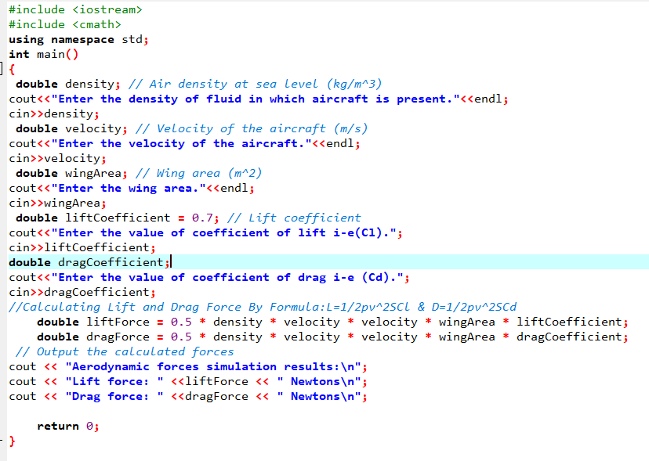

Figure 11 Input

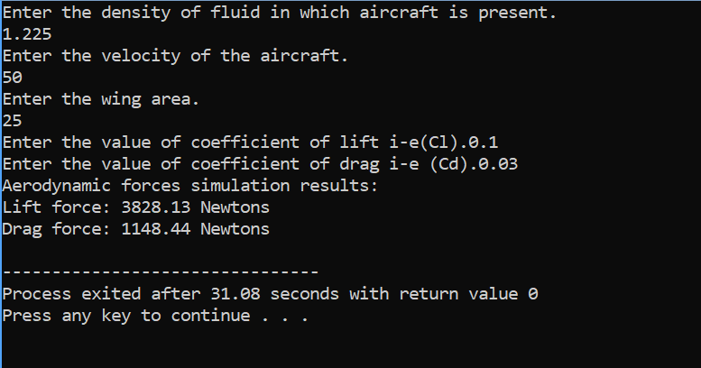

Figure 12 Output

#include <iostream>

#include <cmath>

using namespace std;

int main()

{

double density; // Air density at sea level (kg/m^3)

cout<<"Enter the density of fluid in which aircraft is present."<<endl;

cin>>density;

double velocity; // Velocity of the aircraft (m/s)

cout<<"Enter the velocity of the aircraft."<<endl;

cin>>velocity;

double wingArea; // Wing area (m^2)

cout<<"Enter the wing area."<<endl;

cin>>wingArea;

double liftCoefficient = 0.7; // Lift coefficient

cout<<"Enter the value of coefficient of lift i-e(Cl).";

cin>>liftCoefficient;

double dragCoefficient;

cout<<"Enter the value of coefficient of drag i-e (Cd).";

cin>>dragCoefficient;

//Calculating Lift and Drag Force By Formula:L=1/2pv^2SCl & D=1/2pv^2SCd

double liftForce = 0.5 * density * velocity * velocity * wingArea * liftCoefficient;

double dragForce = 0.5 * density * velocity * velocity * wingArea * dragCoefficient;

// Output the calculated forces

cout << "Aerodynamic forces simulation results:\n";

cout << "Lift force: " <<liftForce << " Newtons\n";

cout << "Drag force: " <<dragForce << " Newtons\n";

return 0;

}

This code represents a basic simulation of aerodynamic forces and can be a starting point for more complex simulations or analyses in aerospace engineering. It allows engineers to input specific parameters and quickly obtain estimates of lift and drag forces on an aircraft's wing based on the provided coefficients and environmental conditions.

**Input:**  **Output:**